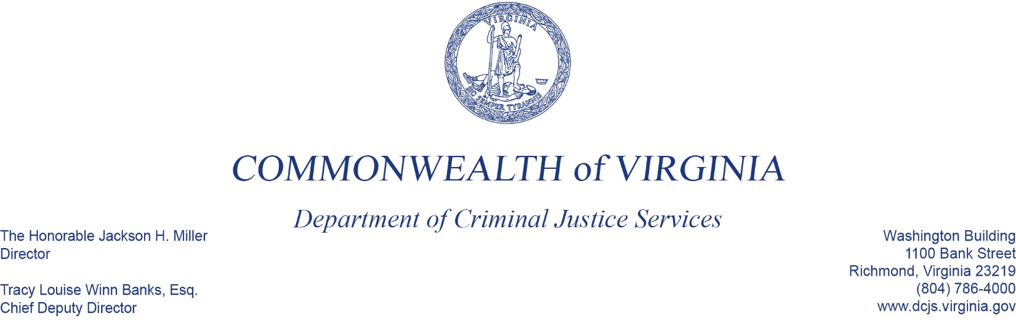
To: Criminal Justice Services Board Grants Committee
From: Kristina Vadas, Manager, Victims Services
Date: June 2, 2022
Re: FY22-23 Victim Witness Grant Program, 12-month award for Year 2

The purpose of the Victim Witness Grant Program (VWGP) is to provide financial support to local victim/witness programs and statewide victim assistance programs designed to provide direct services, information, and assistance required by Virginia’s Crime Victim and Witness Rights Act.

The VWGP will begin year two of a two-year grant cycle in SFY 2023. This grant program is supported primarily with federal Victims of Crime Act (VOCA) funds, as well as state general and special funds.

For SFY 2023, DCJS staff proposes awards totaling $19,257,236 to 113 continuation grantees for SFY 2023 VWGP funding.

As a reminder, in December 2021, the CJSB awarded an 18-month grant in the amount of $118,348 to the County of Rappahannock to start a new victim/witness program. Since this was already approved, it is not included in the above totals, and a vote is not required.

